Project Narrative: Chicago Vision Zero Interactive Dashboard
Civic Technology Development To address traffic safety concerns in Chicago, I designed and deployed a full-stack web application titled "Chicago Vision Zero Dashboard." This project satisfies Competency 6 (Develop civic technology applications for web/mobile platforms) by transforming raw municipal data into an interactive tool accessible to residents and city planners. Built using the R Shiny framework, the application processes over 100,000 crash records to visualize "Vision Zero" metrics—the goal of eliminating traffic fatalities.
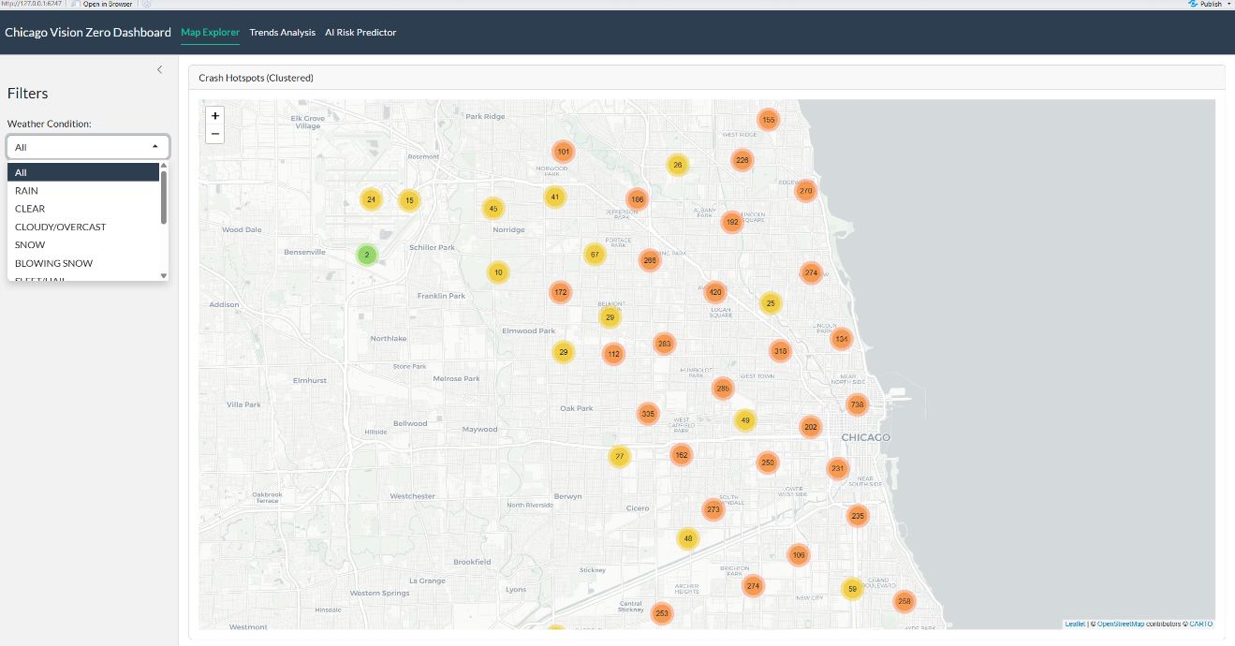
Page 1: Map Explorer (Geospatial Visualization) The first interface functions as a granular spatial exploration tool. I utilized the Leaflet library to plot crash coordinates across Chicago’s 77 community areas. To ensure browser performance and usability, I implemented marker clustering, which groups thousands of data points into readable clusters that expand upon zooming. The interface features dynamic side-panel filters, allowing users to toggle data based on "Weather Condition" and "Season." This functionality empowers users to identify specific intersection "hotspots" that are particularly dangerous during winter months or adverse weather, providing actionable insights for infrastructure improvements.
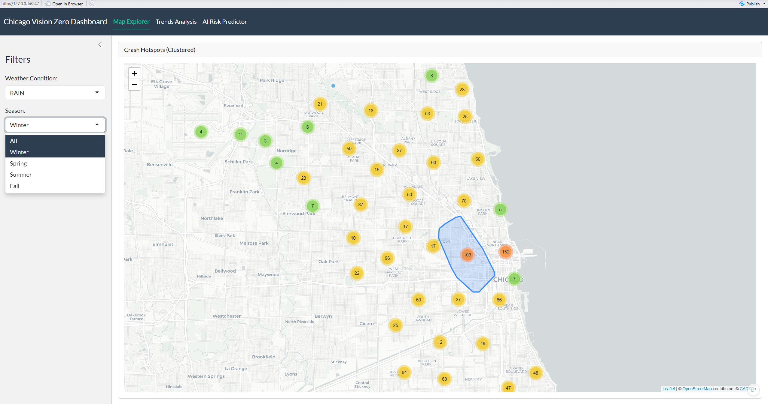
Page 2: Trends Analysis (Data Storytelling) The second page focuses on temporal and environmental pattern recognition. Using Plotly and ggplot2, I developed interactive charts that reveal when and why severe crashes occur.
- Hourly Analysis: A stacked bar chart illustrates the "Injury Rate" by hour, highlighting a critical insight: while traffic volume peaks during rush hour, the probability of injury actually peaks late at night due to higher speeds.
- Environmental Impact: A dynamic comparison chart visualizes how specific road conditions (e.g., wet pavement, poor lighting) correlate with injury severity, helping policymakers prioritize street lighting and road maintenance in high-risk zones.
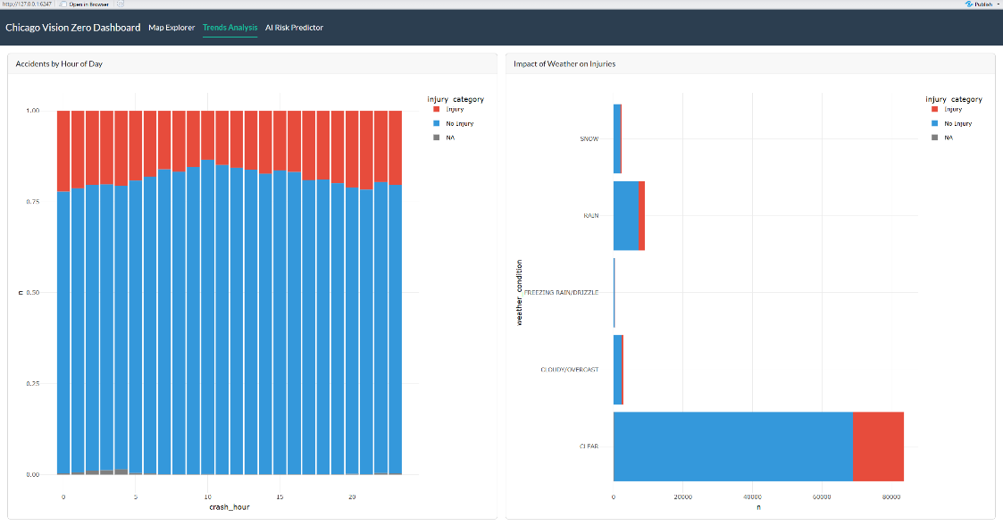
Page 3: AI Risk Predictor (Machine Learning Integration) The final page represents the most advanced feature: a real-time predictive interface powered by an XGBoost (Gradient Boosting) machine learning model.
- Hierarchical UX Design: I designed a "Cascading Input" system where users first select a broad "City Side" (Region), which dynamically updates the "Neighborhood" dropdown. This ensures the model uses robust regional data while allowing users to select their specific community.
- Real-Time Simulation: Users can simulate various scenarios (e.g., "Driving in Hyde Park, at 2 AM, in the Rain"). The app passes these inputs to the backend AI model, which instantly calculates a "Probability of Injury" score and displays a color-coded Risk Badge (Low/Medium/High), effectively translating complex statistical probabilities into simple, life-saving risk assessments for the public.
